Folder structure
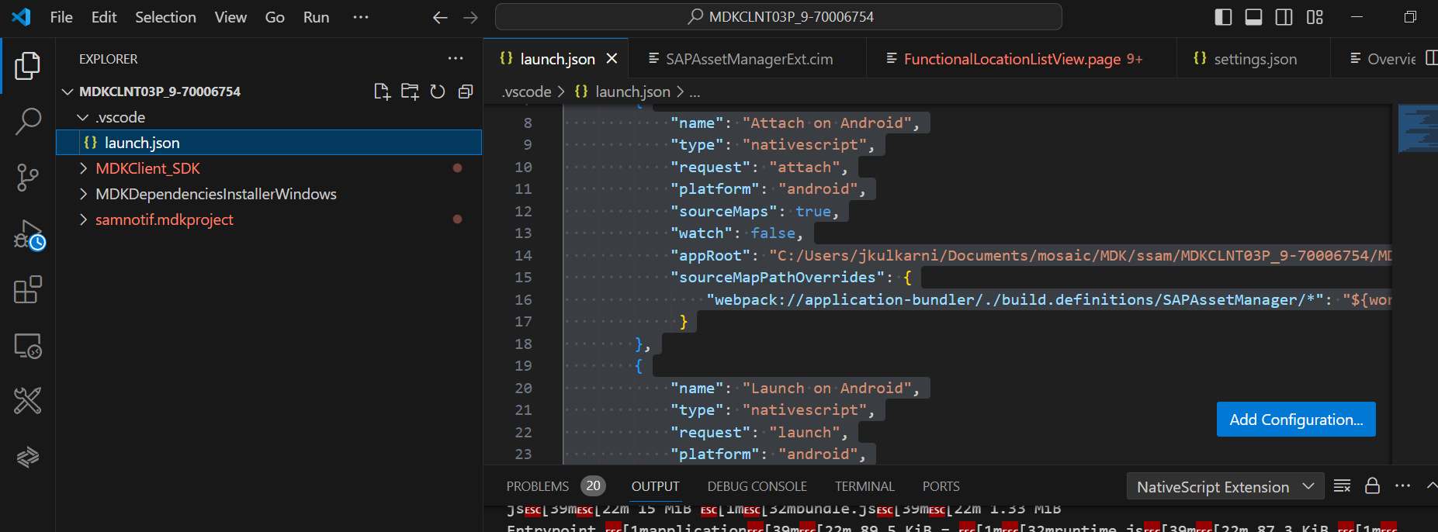

Launch.json

{
// Use IntelliSense to learn about possible attributes.
// Hover to view descriptions of existing attributes.
// For more information, visit: https://go.microsoft.com/fwlink/?linkid=830387
"version": "0.2.0",
"configurations": [
{
"name": "Attach on Android",
"type": "nativescript",
"request": "attach",
"platform": "android",
"sourceMaps": true,
"watch": false,
"appRoot": "C:/Users/jkulkarni/Documents/mosaic/MDK/ssam/MDKCLNT03P_9-70006754/MDKClient_SDK/SvcAssetMgr",
"sourceMapPathOverrides": {
"webpack://application-bundler/./build.definitions/SAPAssetManager/*": "${workspaceRoot}/samnotif.mdkproject/metadata/SAPAssetManager/*"
}
},
{
"name": "Launch on Android",
"type": "nativescript",
"request": "launch",
"platform": "android",
"sourceMaps": true,
"watch": true,
"appRoot": "C:/Users/jkulkarni/Documents/mosaic/MDK/ssam/MDKCLNT03P_9-70006754/MDKClient_SDK/SvcAssetMgr",
"sourceMapPathOverrides": {
"webpack://application-bundler/./build.definitions/SAPAssetManager/*": "${workspaceRoot}/samnotif.mdkproject/metadata/SAPAssetManager/*"
}
},
]
}

Settings.json
{
"build-output": "build.definitions",
"create-bundle": false,
"editor-export": "",
"nativescript-project": "../../SvcAssetMgr/app",
"seam-project": "../../../samnotif.mdkproject/metadata/SAPAssetManager",
"watch": false,
"devtool": "source-map",
"externals": ["@nativescript/geolocation", "extension-MapFramework", "uuid"],
"NSPlugins": ["@nativescript/geolocation"],
"NPMPlugins": ["uuid"]
}

Build app

C:\Users\jkulkarni\Documents\mosaic\MDK\ssam\MDKCLNT03P_9-70006754\MDKClient_SDK\tools\application-bundler>node bundler-cli.js

